Coronal Abundances from Solar Energetic Particle Measurements Made at 20 to 60 MeV/nucleon

C. M. S. Cohen, R. A. Mewaldt, R. A. Leske, A. C. Cummings, E. C. Stone
George W. Downs Laboratory of Physics, California Institute of Technology, Pasadena, California, USA
G. M. Mason, M. I. Desai
University of Maryland, College Park, MD, USA
M. E. Wiedenbeck
Jet Propulsion Laboratory, Pasadena, CA, USA
T. T. von Rosenvinge
NASA/Goddard Space Flight Center, Greenbelt, MD, USA
Abstract: Observations from the Solar Isotope Spectrometer (SIS) and the Ultra Low Energy Isotope Spectrometer (ULEIS) on the ACE spacecraft during the extremely large events of October and November 2003 were combined to create heavy ion spectra over more than 3 decades in energy. The resulting spectra differed substantially in shape from event to event, as well as from element to element within a given event resulting in energy-dependent abundance ratios. When examined as a function of rigidity, some of these variations are reduced and rigidity-independent abundances can be obtained if the charge states of Mg, Si, and Fe are assumed to increase with increasing rigidity. The required increase for Fe ranges from 12 to 28% between the events, with Mg and Si needing between 2 and 15%. The effects of strong local shock acceleration is apparent in the events of 28 and 29 October, which also exhibit generally softer iron energy spectra. Increases in the Fe/O ratio with increasing energy were seen in the two more western events (2 and 4 November) but the ratios did not exceed the nominal abundance of 0.134, suggesting little contribution of flare material.

Introduction
To call the period of 25 October - 11 November, 2003 a solar ‘active’ period would be an extreme understatement. During these 18 days, there were 43 coronal mass ejections (CMEs) identified with the LASCO coronagraph on SOHO, 22 of which had speeds in excess of 800 km/s [Gopalswamy et al., 2004]. There were also 8 X-class flares, including the largest ever recorded on November 4 (http://www.sec.noaa.gov/Data/index.html). Not surprisingly, these flares and CMEs gave rise to a series of large solar energetic particle (SEP) events; some of the largest of this solar cycle. At ~50 MeV/nucleon, oxygen intensities show 5 distinct events (Figure 1), 4 of which can be matched to flares occurring in active region 10486 as it moved across the solar disk (the first event matches a flare in active region 10484; Table 1). Just upstream of the Earth, at least 7 interplanetary shocks were observed with shock normal angles ranging from 14 to 80 degrees (Table 2). Several of these were still accelerating particles as evidenced by the coincident increases in ≤ 1 MeV/nucleon oxygen intensities.
The October/November, 2003 time period provides a unique opportunity to examine a series of SEP events originating from the same active region as it moved across the solar disk. During this transit it is likely that aspects influencing SEP acceleration, such as magnetic connection to the flare, available seed population, and shock strength/orientation/etc, changed significantly. Whether the impact of such variations can be seen in the energetic particle composition and spectra, or possibly inferred from the observations, is worth investigating as it furthers the understanding of the generation of large SEP events and their characteristics. Knowledge of the causes of abundance variations, particularly as a function of energy, is crucial to making accurate assessments of radiation hazards, both for astronauts and sensitive space-based instruments.

Instrumentation and Data Analysis
The Advanced Composition Explorer (ACE) resides at the L1 point between the Earth and the Sun, providing a monitor of energetic particles and plasma conditions that will shortly impact the Earth [Stone et al., 1998b]. The energy spectra and elemental, isotopic, and ionic charge composition of energetic particles from many large SEP events have been measured by the ACE sensors since September 1997. The heavy ion data presented here are from two of the energetic particle detectors on the spacecraft; the Ultra-Low Energy Isotope Spectrometer (ULEIS) [Mason et al., 1998] and the Solar Isotope Spectrometer (SIS) [Stone et al., 1998a]. ULEIS utilizes time-of-flight measurements to determine ion mass and energy for ions from ~0.1 to 10 MeV/nucleon, while SIS employs dE/dx versus residual energy measurements to obtain nuclear charge and total energy for ions from ~7 to 100 MeV/nucleon. The high resolution and large geometry factors of these two instruments allow spectra for ions from C to Fe to be accurately determined over a wide energy range.
Five events are readily identified in the oxygen ~50 MeV/nucleon SIS intensities shown in Figure 1. In the SIS energy range there is negligible velocity dispersion in the onsets of the different energy channels, so fluences were calculated over simple time intervals as given in Table 3. At ULEIS energies, where dispersion is more substantial, the time intervals for each event are energy dependent and determined from examining particle velocity versus time plots. As the fluences obtained from the ULEIS data are dominated by the peak intensity time periods, the results are not very sensitive to the details of the energy-dependent time intervals.
During time periods of high particle intensity, an automatic door reduces opening aperture of ULEIS. This was done for 4 of the 5 events studied here; the door was 1% open during events 2, 3, and 4, and 6% open during event 5. This helps prevent saturation and dead time problems in the instrument. However, even with a 1% door position, there were significant dead time effects from ~10:20 UT, 28 October through 13:00 UT, 29 October due to penetration of the instrument walls by high energy particles. Dead time corrections for this period were calculated by comparing the ULEIS and SIS oxygen intensities at overlapping energy intervals.

The Five Large Events
The largest of the 5 events studied here, starting on 28 October, is also one of the most intense events seen by the SIS instrument since launch in August 1997. Figure 2 shows hourly intensities of 10 MeV/nucleon oxygen for a 4 day period centered around the time of peak intensity for 5 of the largest events previously measured by SIS. Although the peak is brief, the intensity of the 4 November 2001 event is slightly higher than that of 28 October 2003 (0.79 vs 0.74 (cm² sr sec MeV/n)⁻¹). However, when the event-integrated fluence is calculated as a function of energy (Figure 3), it is clear that the 28 October event is the largest by a substantial factor.
In a broader context, the fluence of this event can be compared to measurements made with different instruments in the past (although several of the very largest events, e.g., 4 August 1972 and 23 February 1956, were not observed with instruments capable of measuring oxygen fluences). This is done for the events of 6 November 1997, 2 November 1992, 23 September 1978, and 19 October 1989 in Figure 3. The 28 October 2003 event is second to the 19 October 1989 event over the energies measured, however if one were to extrapolate to energies above 100 MeV/nucleon it is possible that the 28 October 2003 event would emerge as the largest. Interestingly, significantly smaller events such as 6 November 1997 and 2 November 1992 have substantially harder spectra which could result in them being the events of significance at energies of ~500 MeV/nucleon and greater. This illustrates the need for radiation hazard estimations to incorporate differences in spectral shapes seen from event to event.
This variability is apparent even for the 5 events of October/November 2003. The fluence spectra for each event is determined from 0.1 to 80 MeV/nucleon by combining the observations of the ULEIS and SIS instruments (Figure 4). Although all the events have a bend in the spectra near 1-10 MeV/nucleon, their behavior at energies on either side of this bend differ significantly. The often used ‘power law x exponential’ spectral form from Ellison and Ramaty [1985], in which the lower energies are characterized by a power law and the higher energies by an exponential, only appears to adequately describe the iron and oxygen spectra of the second event (28 October). An expectation of this form (which we will refer to as ‘ER-type spectra’) is that the e-folding energy for different elements is anti-correlated with the ion charge-to-mass (Q/M) ratios. This generally results in strongly falling Fe/O ratios with increasing energies, as is seen for this event (Figure 5).
Another common spectral shape is a double power law spectrum [Mewaldt et al., 2004; Tylka et al., 2004], with event-independent spectral indices. The 29 October event is an example of this, with Fe/O ratios approximately constant on either side of the break. Events on 26 October and 2 November deviate from this shape at the low and high energies, respectively, producing large energy dependencies in their Fe/O ratios (Figure 5). Finally, the 4 November event appears to have vastly different O and Fe spectral shapes, with Fe/O ratios varying almost 2 orders of magnitude over the energy range measured.
By further integrating the elemental spectra over two energy ranges, the composition for many elements can be compared for the 5 events. In the top panels of Figure 6, the abundances from ULEIS for 0.64 to 0.91 MeV/nucleon and SIS from 12 to 60 MeV/nucleon, relative to oxygen, are given as a function of nuclear charge. The bottom panels are again normalized to the average large SEP event abundances of Reames [1999], which are often used as the standard for large SEP event composition. Although there are significant differences between events (particularly for Ar-Ni), the dissimilarity between the abundance patterns at the two energies is most striking. All the events are enhanced (relative to the typical values of Reames) in ions heavier than Ne at ULEIS energies, while all but two events are depleted in ions heavier than Si at SIS energies.
Although it is often assumed that the compositional variability increases with increasing energy [Reames and Ng, 2004], the event to event variation is nearly as large near 1 MeV/nucleon as it is above 10 MeV/nucleon. Interestingly, for Ca-Ni at 12-60 MeV/nucleon, the events divide into two groups, with events 1 and 3 having close to nominal abundances and events 2, 4, and 5 being depleted in heavy ions. A corresponding pattern does not appear at 0.64-0.91 MeV/nucleon, where the variation is more uniform. Indeed, even the ordering of the events by increasing X/O ratio (e.g., Fe/O or C/O) is not preserved between the two energy intervals; i.e., the events that have the highest Si/O ratios at lower energies are not the same events that are richest in Si/O at higher energies.

Shock Spectra Evolution
Three of the seven shocks that were observed by ACE during this time period had concurrent increases in the oxygen particle intensities above 5 MeV/nucleon (29 and 30 October and 4 November), suggesting significant local particle acceleration by the shocks. The oxygen spectra for 5 hours before and after the passages of these shocks are shown in Figure 7; in all 3 cases the spectra after the shock passage are fairly invariant and well characterized by a double power law or ER-type spectra. The spectral shapes of many other elements, in addition to oxygen, for these shocks are discussed in Mewaldt et al. [2004], where the authors discuss the organization of the break points of the spectra (as a function of nuclear charge or Q/M).
Moving from -5 hours to -1 hour, the spectra unroll with the peak intensity shifting to lower energies until the arrival of the shock while the spectra above ~10 MeV/nucleon remain approximately unchanged. The strong difference between the three passages is the energy at which the peak occurs at -5 hours; nearly 10 MeV/nucleon for the 29 October shock, ~1 MeV/nucleon for the 30 October shock, and below 1 MeV/nucleon for the 4 November shock. One interpretation of this peak is that the shock is unable to contain particles above the corresponding energy (E_{peak}) and they subsequently leak out of the shock region and are detected upstream. Lower energy ions are trapped in the shock region and not observed until the shock arrival. The value of E_{peak} would be dependent on the strength of the shock, with stronger shocks having higher values [Rice et al., 2003]. This implies that the 29 October shock was stronger than the other two, although its transit time (relative to the observed CME) was the same as that of the 30 October shock (see Table 2).
The contribution of locally accelerated ions from these shocks to the event-integrated fluences is discussed in the next section, where an attempt is made to understand the differences between the 5 events. Other aspects, such as the contribution of flare material and rigidity-related effects, are also examined. The key observations to be explained are 1) the substantially varied spectral shapes from event to event, 2) the different O and Fe spectral shapes within each event, and 3) the resulting energy-dependent composition (which also varies in trend from one event to the next).

Discussion
Although 4 of the 5 events studied here were related to flares that originated in the same active region, the oxygen and iron spectra differ significantly from one event to the next. That the shapes of the oxygen and iron spectra are different within each event gives rise to energy-dependent Fe/O ratios. It can also be inferred from the changing abundance patterns with respect to nuclear charge (Z) seen at two energy intervals, that the spectral shapes of other elements differ from that of oxygen as well. However, it is unclear whether a systematic trend from element to element can be found. While the enhancements of heavy ions (relative to nominal large SEP event abundances) increase with increasing Z at ULEIS energies for most of the events, this pattern does not continue into the higher SIS energies. In fact, 3 of the 5 events show large depletions of ions heavier than Ar in the SIS data.
One could argue that event integrated spectra over more than 3 decades in energy is not a useful tool in examining these complicated events. The time-intensity plot (Figure 1) clearly shows very dissimilar behavior at 1 and 50 MeV/nucleon. In at least 3 of the events, the lower energy intensities are dominated by the peak coincident with a shock passage, while higher energy particles show a prompt rise peaking before the shock and decaying fairly rapidly. If one assumes that the intensity increase at the shock is a sign of local shock acceleration [Lee, 1983] and that higher energy ions are accelerated much closer to the Sun [Kahler, 1994; Mewaldt et al., 2003], then the intensities represent an evolution (with decreasing energy) of acceleration from close to the Sun, through the interplanetary medium, to nearly 1 AU. It is likely that properties of the shock, such as normal angle and strength or speed, vary as it moves from the Sun to 1 AU and that the available seed population for acceleration also varies, with perhaps flare material being more prevalent closer to the Sun. As both the characteristics of the shock and the composition of the seed population contribute to the spectral shape and composition of the resulting accelerated ions, it is likely that event-integrated spectra over a large energy range will have energy-dependent composition and complicated spectral shapes.
In an effort to explore this idea in more detail, two energy values have been identified for each event through visual examination of the time-intensity plot. The lower energy (E_{shock}) is the maximum energy at which there is a clear increase in the intensities coincident with a shock passage. The higher energy (E_{prompt}) is the minimum energy at which the intensities are insensitive to the shock passage. These values are given in Table 3 for each event. The O, Fe and Fe/O spectra plots were then examined to determine if the region above E_{prompt} or the region below E_{shock} have characteristics that are similar in all 5 events.
In the second and third events (28 and 29 October, respectively) the value of E_{prompt} is so high that it suggests that the entire spectrum is dominated by shock acceleration very near the spacecraft. As a rudimentary check on this the event-integrated oxygen spectra are compared with those obtained 2 hours after the shock passages; this is done for events 2, 3, and 4 in Figure 8. The match for event 3 is particularly good, although event 2 shows strong similarities between the event-integrated spectrum and shock spectrum below 10 MeV/nucleon. In contrast, the match is poor for event 4 where the value of E_{prompt} is significantly lower suggesting that a larger portion of the spectrum was accelerated closer to the Sun. In this event the spectrum above E_{prompt} is substantially harder than the spectrum seen just after the shock passage.
Events 1 and 5 (26 October and 4 November) both have low values of E_{prompt} and also have the hardest Fe spectra above 10 MeV/nucleon of the 5 events. This and the Fe spectrum of event 4 is consistent with the model that a shock would be stronger closer to the Sun and thus able to acceleration more ions to higher energies [Zank et al., 2000]. Additionally, the lack of a large local shock affect on these events could be due to ACE observing the flanks of the shocks rather than the nose. This possibility is supported by the fact that the shock transit times (relative to the CME times) were nearly twice as long as that of the shock-dominated events (28 and 29 October) and the related flares were well removed from the Sun’s central meridian.
Events 1, 4, and 5 have another similarity as well; all 3 exhibit a large peak in the Fe/O ratio in the region 0.1-1 MeV/nucleon, whereas the shock-related events have more constant Fe/O ratios below a few MeV/nucleon. This peak is related to the bend in the Fe spectra which occurs at lower energies than the bend in the oxygen spectra. The spectral breaks are related to the turbulence near the shock that is scattering the heavy ions and confining them to the shock region. At some energy, dependent on the shock characteristics, the turbulence is unable to efficiently trap the ions and they leak out of the shock area producing a roll-off in the spectrum [Zank, private communication 2004]. That the breaks in the Fe spectra occur near the same energy in each of the three events suggests that the related shocks were similar, consistent with the comparable observed transit times. Since the break energies for O and Fe are different indicates that the leakage is not simply a function of particle energy.
Above 10 MeV/nucleon the behavior of events 1 and 5 are very different, although events 4 and 5 show similar increases in the Fe/O ratio with increasing energy. Energy-dependent Fe/O ratios above 10 MeV/nucleon have been discussed before; in particular, increasing Fe/O ratio with increasing energy has been argued to be a result of direct access to flare material [Cane et al., 2003] and reacceleration of flare suprathermals by quasi-perpendicular shocks [Tylka et al., 2004]. However, both these studies involved Fe/O ratios enhanced over the nominal large SEP event value of 0.134. Such enhancements are not seen in either the event-integrated abundances or the hourly intensities at energies above 10 MeV/nucleon for these events. Thus, it does not appear to be useful to interpret the results presented here within the framework of the Tylka et al. or Cane et al. studies.
It may be useful to examine the elemental spectra as function of rigidity rather than energy per mass (E/m), as many aspects of shock acceleration and particle transport depend on ion rigidity [Ng et al., 2003, and references therein]. However, in order to calculate rigidity the charge state of the ion must be known and these measurements over the energy range of ULEIS and SIS have not been made for heavy ions in these events. Instead we use the average measured charge states obtained in many large SEP events between 0.18 and 0.44 MeV/nucleon: 6.8, 8.9, 9.5, and 11.6 for O, Mg, Si, and Fe respectively [Klecker et al., 2000; Mobius et al., 2000]. The resulting rigidity fluences of O, Mg, Si, and Fe are shown in Figure 9 for all 5 events, with all but the oxygen spectra scaled by differing factors so that their shapes can be better compared. For Fe, the gap between the upper energy limit of the ULEIS data and the lower energy SIS data (i.e., 300-760 MV; 6 points in the spectra) has been filled by interpolating along a power law curve. Smaller gaps in Mg and Si have been handled in the same manner (280-370 MV, 2 points and 270-430 MV, 3 points, respectively).
Although there are still differences in the spectra, they look more alike when plotted versus rigidity than E/m. In particular the position of the break points for the four species occur at approximately the same rigidity within an event. The power laws above the break have spectral indices that roughly increase (harden) with increasing mass in all of the events, while below the break O, Mg, and Si track each other but Fe does not. This is particularly the case for the events that are less dominated by local shock acceleration, 26 October and 2 and 4 November. The resulting elemental ratios (relative to oxygen) versus rigidity (Figure 10) still show variability but the event to event behavior is more consistent than when viewed as a function of E/m, with all the events exhibiting increasing ratios with increasing rigidity.
Although a single charge state has been assumed for the entire energy range (to calculate rigidity), there is strong evidence that the charge states in large SEP events are energy dependent, most noticeably for Fe [Mazur et al., 1999; Mobius et al., 1999; Oetliker et al., 1997]. An interesting exercise is to determine what charge state would be required at each point in the Mg, Si, and Fe spectra to align it with that of O (for Fe this was only attempted above the Fe break at ~200 MV due to the different O and Fe behavior at lower rigidities). The resulting charge state versus rigidity is shown in Figure 11. Rather surprisingly, the charge states do not need to increase much with rigidity in order to obtain rigidity-independent abundances; Mg and Si require perhaps 1- 2 units of charge increase and Fe between 2 and 4 (Table 4). This well within observed variations; measured mean charge states for Fe in the 6 November 1997 SEP event showed an increase from 11 to 14.5 over 0.18-0.54 MeV/nucleon [Mobius et al., 1999], and 12.6 to 13.9 over 0.5 to 2.5 MeV/nucleon [Mazur et al., 1999]. In the 31 October and 2 November 1992 events, charge states for many heavy ions were determined from 4 to 50 MeV/nucleon with instruments on the SAMPEX spacecraft [Oetliker et al., 1997]. The authors plotted charge state versus rigidity and found that the Fe charge state increased from ~11 to ~16 over the range of 330 MV to 650 MV, while Mg showed no change discernable beyond the ±1 charge unit scatter of the data.
It should be emphasized that the increases in charge states derived here are relative to the assumed charge states used to initially create the rigidity spectra. What this exercise has shown is that a modest increase of between 12 and 28% in the Fe charge state from 200 to 900 MV can produce Fe/O ratios that are independent of rigidity in these 5 events and smaller changes are required for Mg and Si (Table 4). Clearly, accurate knowledge of the charge state of heavy ions as a function of energy or rigidity is needed to better understand the compositional variations.

Conclusions
The extremely active period of 25 October - 11 November resulted in 5 readily identified SEP events above 10 MeV/nucleon. The observations of the ULEIS and SIS sensors have been combined to obtain elemental spectra and abundances over more than 3 decades in energy. These data indicate that although the second event, starting on 28 October, did not have the highest hourly peak oxygen intensity measured by SIS at 10 MeV/nucleon, the event-integrated fluence surpassed that of all SEP events observed by ACE since launch in fall of 1997. However, this event still falls short of the very large event of 19 October 1989 (and presumably those of 4 August 1972 and 23 February 1956, although oxygen intensities were not obtained for these events).
Although 4 of the 5 events studied here are related to flares which originated in the same active region as it moved across the solar disk, the spectra differ substantially from one SEP event to the next. In addition, the Fe and O spectra for a given event do not have the same shape, resulting in energy-dependent Fe/O ratios for all 5 events. By examining the temporal evolution of the oxygen intensity at many different energies, the effect of local shock acceleration on the event-integrated spectra was evaluated. The shock-dominated events of 28 and 29 October have softer spectra and less variable Fe/O ratios below a few MeV/nucleon. In contrast, there was little local shock acceleration in the events of 26 October, 2 and 4 November, where the Fe spectra were harder and Fe/O ratios exhibited a peak between 0.1 and 1 MeV/nucleon. For those events with little local shock influence, the different break points in the spectra for O and Fe indicate escape from the shock region is related to something other than energy/mass. That all three of these events have breaks in the Fe spectra at similar energies suggests that the related shocks had similar characteristics.
Transforming the energy spectra into rigidity spectra (by assuming charge states for O, Mg, Si, and Fe) produced more monotonic variations in the Fe/O ratio and appeared to better organize the break points of the spectra of all 4 species. Assuming a charge state that increases with increasing rigidity between 12 and 28% for Fe, and less for Mg and Si, would produce rigidity-independent abundance ratios. Such increases have certainly been observed and suggest that knowledge of the charge states of heavy ions, particularly as a function of energy, is key to understanding the abundance variations seen in such large SEP events. They may also provide more clues regarding the seed populations being accelerated close to the Sun and through the interplanetary medium. Similarly SEP and plasma measurements at smaller radial distances, such as those proposed by the Solar Probe and Sentinels missions, as well as simultaneous SEP measurements at different solar longitudes, such as will be possible with the STEREO mission, are also strongly needed.

Acknowledgments. This work was supported by NASA at the California Institute of Technology (under grant NAG5-6912), the Jet Propulsion Laboratory, NASA/Goddard Space Flight Center, and in part under Caltech grant 44A1055749 at the University of Maryland.

References Cited

Cane, H.V., T.T. von Rosenvinge, C.M.S. Cohen, and R.A. Mewaldt, Two Components In Major Solar Particle Events, Geophysical Research Letters, 30, 2003.
Cook, W.R., Elemental Composition of Solar Energetic Particles, Ph.D. Thesis, California Institute of Technology, Pasadena, CA, 1981.
Ellison, D.C., and R. Ramaty, Shock Acceleration Of Electrons And Ions In Solar Flares, Astrophysical Journal, 298, 400-408, 1985.
Garrard, T.L., and E.C. Stone, Heavy Ions in the October 1989 Solar Flares Observed on the Galileo Spacecrat, in 22nd International Cosmic Ray Conference, pp. 331-334, Dublin, Ireland, 1991.
Gopalswamy, N., S. Yashiro, Y. Liu, G. Michalek, A. Vourlidas, M.L. Kaiser, and R.A. Howard, Coronal Mass Ejections and other Extreme Characteristics of the 2003 October-November Solar Eruptions, Journal of Geophysical Research, this issue, 2004.
Kahler, S., Injection Profiles Of Solar Energetic Particles As Functions Of Coronal Mass Ejection Heights, Astrophysical Journal, 428, 837-842, 1994.
Klecker, B., A.T. Bogdanov, M. Popecki, R.F. Wimmer-Schweingruber, E. M√∂bius, R. Schaerer, L.M. Kistler, A.B. Galvin, D. Heirtzler, D. Morris, D. Hovestadt, and G. Gloeckler, Comparison of Ionic Charge States of Energetic Particles with Solar Wind Charge States in CME Related Events, in AIP Conf. Proc. 528: Acceleration and Transport of Energetic Particles Observed in the Heliosphere, pp. 135, 2000.
Lee, M.A., Coupled Hydromagnetic Wave Excitation And Ion Acceleration At Interplanetary Traveling Shocks, Journal of Geophysical Research, 88, 6109-6119, 1983.
Mason, G.M., R.E. Gold, S.M. Krimigis, J.E. Mazur, G.B. Andrews, K.A. Daley, J.R. Dwyer, K.F. Heuerman, T.L. James, M.J. Kennedy, T. Lefevere, H. Malcolm, B. Tossman, and P.H. Walpole, The Ultra-Low-Energy Isotope Spectrometer (ULEIS) for the ACE spacecraft, Space Science Reviews, 86, 409-448, 1998.
Mazur, J.E., G.M. Mason, M.D. Looper, R.A. Leske, and R.A. Mewaldt, Charge States Of Solar Energetic Particles Using The Geomagnetic Cutoff Technique: SAMPEX Measurements In The 6 November 1997 Solar Particle Event, Geophysical Research Letters, 26, 173-176, 1999.
Mewaldt, R.A., C.M.S. Cohen, D.K. Haggerty, R.E. Gold, S.M. Krimigis, R.A. Leske, R.C. Ogliore, E.C. Roelof, E.C. Stone, T.T. von Rosenvinge, and M.E. Wiedenbeck, Heavy Ion And Electron Release Times In Solar Particle Events, International Cosmic Ray Conference, 28th, Tsukuba, Japan, 6, 3313-3316, 2003.
Mewaldt, R.A., C.M.S. Cohen, R.A. Leske, E.C. Stone, A.C. Cummings, T.T. von Rosenvinge, M.E. Wiedenbeck, and G. Li, Something about spectral breaks, Journal of Geophysical Research, this volume, 2004.
Mobius, E., B. Klecker, M.A. Popecki, D. Morris, G.M. Mason, E.C. Stone, A.T. Bogdanov, J.R. Dwyer, A.B. Galvin, D. Heirtzler, D. Hovestadt, L.M. Kistler, and C. Siren, Survey of Ionic Charge States of Solar Energetic Particle Events During the First Year of ACE, in AIP Conf. Proc. 528: Acceleration and Transport of Energetic Particles Observed in the Heliosphere, pp. 131, 2000.
Mobius, E., M. Popecki, B. Klecker, L.M. Kistler, A. Bogdanov, A.B. Galvin, D. Heirtzler, D. Hovestadt, E.J. Lund, D. Morris, and W.K.H. Schmidt,I, Geophysical Research Letters, 26, 145-148, 1999.
Ng, C.K., D.V. Reames, and A.J. Tylka, Modeling Shock-accelerated Solar Energetic Particles Coupled to Interplanetary Alfven Waves, Astrophysical Journal, 591, 461-485, 2003.
Oetliker, M., B. Klecker, D. Hovestadt, G.M. Mason, J.E. Mazur, R.A. Leske, R.A. Mewaldt, J.B. Blake, and M.D. Looper, The Ionic Charge of Solar Energetic Particles with Energies of 0.3--70 MeV per Nucleon, Astrophysical Journal, 477, 495, 1997.
Reames, D.V., Particle Acceleration At The Sun And In The Heliosphere, Space Science Reviews, 90, 413-491, 1999.
Reames, D.V., and C.K. Ng, Heavy-Element Abundances in Solar Energetic Particle Events, Astrophysical Journal, 610, 510-522, 2004.
Rice, W.K.M., G.P. Zank, and G. Li, Particle Acceleration And Coronal Mass Ejection Driven Shocks: Shocks Of Arbitrary Strength, Journal of Geophysical Research (Space Physics), 108j, 2003.
Stone, E.C., C.M.S. Cohen, W.R. Cook, A.C. Cummings, B. Gauld, B. Kecman, R.A. Leske, R.A. Mewaldt, M.R. Thayer, B.L. Dougherty, R.L. Grumm, B.D. Milliken, R.G. Radocinski, M.E. Wiedenbeck, E.R. Christian, S. Shuman, and T.T. von Rosenvinge, The Solar Isotope Spectrometer for the Advanced Composition Explorer, Space Science Reviews, 86, 357-408, 1998a.
Stone, E.C., A.M. Frandsen, R.A. Mewaldt, E.R. Christian, D. Margolies, J.F. Ormes, and F. Snow, The Advanced Composition Explorer, Space Science Reviews, 86, 1-22, 1998b.
Tylka, A.J., C.M.S. Cohen, W.F. Dietrich, M.A. Lee, C.G. Maclennan, R.A. Mewaldt, C.K. Ng, and D.V. Reames, Shock Geometry, Seed Populations, And The Origin Of Variable Elemental Composition At High Energies In Large Gradual Solar Particle Events, Astrophysical Journal, submitted, 2004.
Williams, D.L., Measurements of the Isotopic Composition of Solar Energetic Particles with the MAST Instrument aboard the SAMPEX Spacecraft, Ph.D. Thesis, California Institute of Technology, Pasadena, CA, 1998.
Zank, G.P., W.K.M. Rice, and C.C. Wu, Particle Acceleration And Coronal Mass Ejection Driven Shocks: A Theoretical Model, Journal of Geophysical Research, 105, 25079-25096, 2000.

Figures
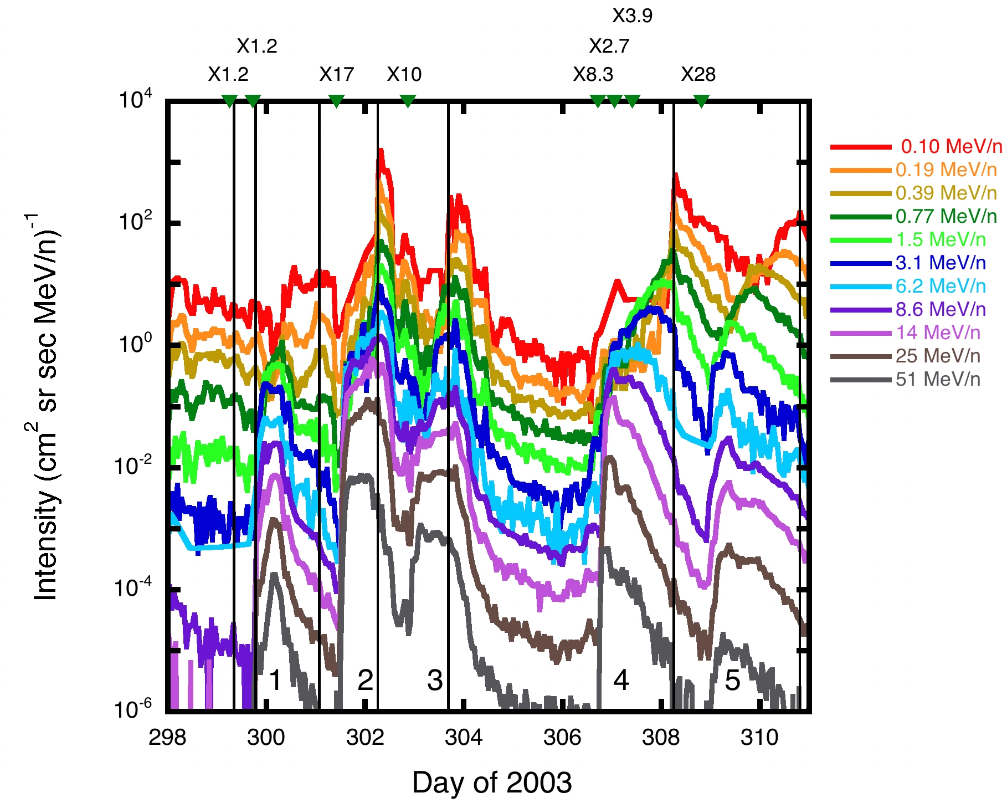
Figure 1. Hourly oxygen intensity is plotted versus time for several of the ULEIS and SIS energy bands. Flares are indicated by the inverted triangles at the top of the plot (with flare size given above). Shock passages are denoted by the vertical solid lines and the 5 identified events are numbered for reference.
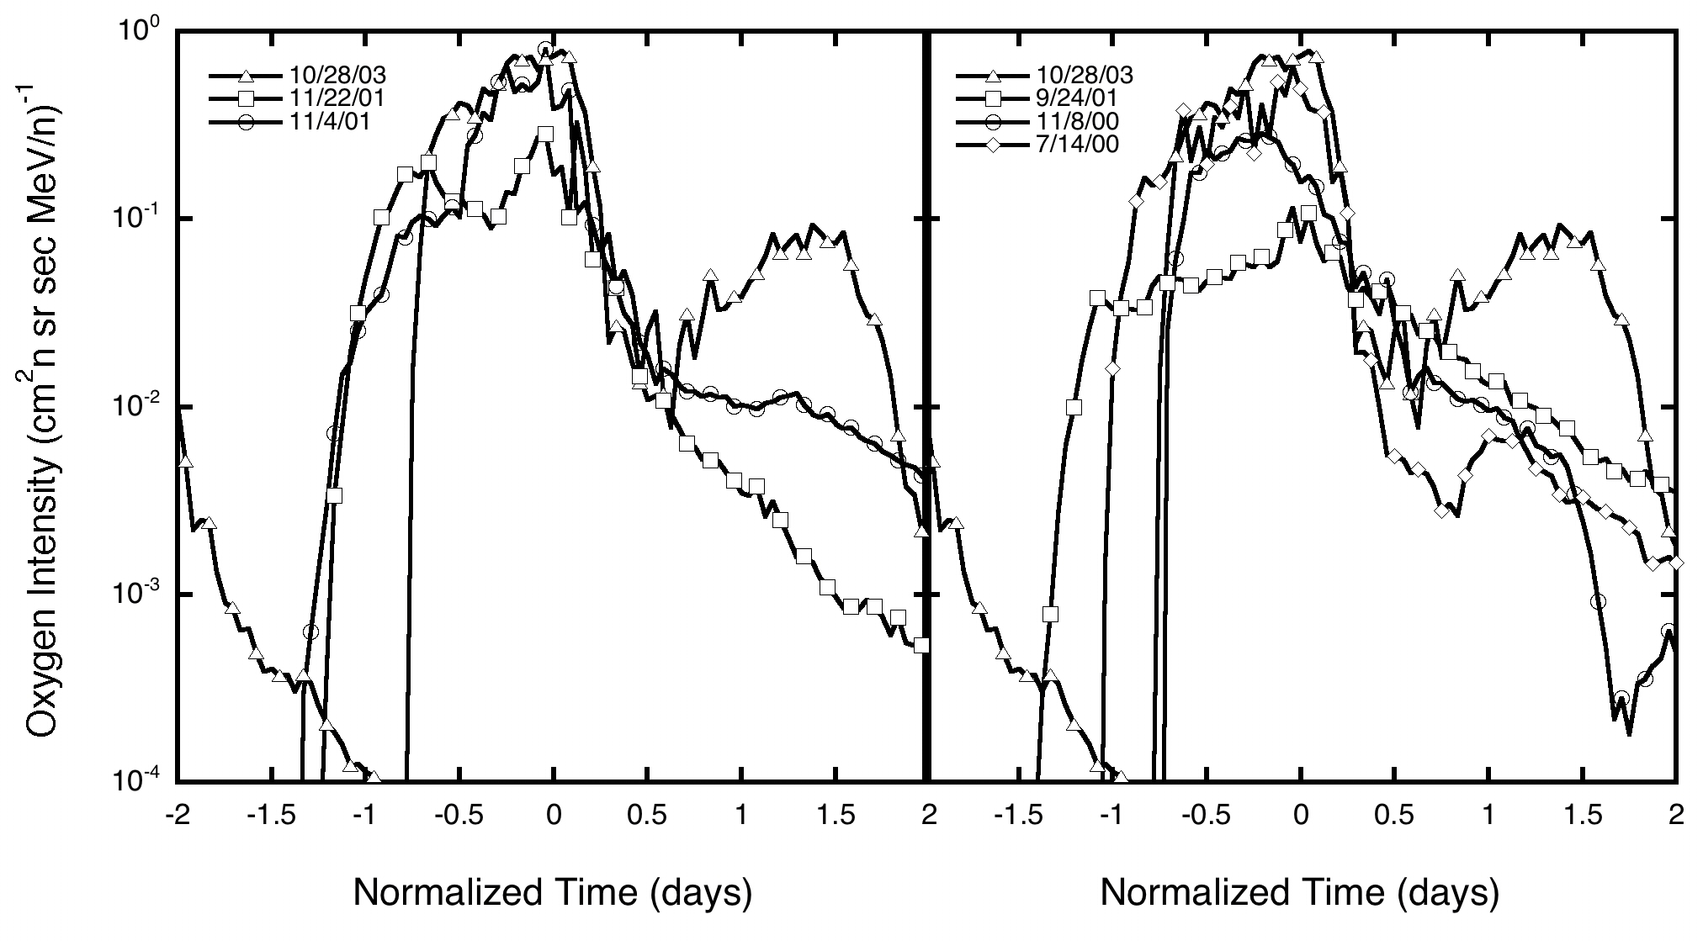
Figure 2. Hourly intensities of 10 MeV/nucleon oxygen are plotted versus time (centered at the time of peak intensity) for 6 events as measured by SIS.

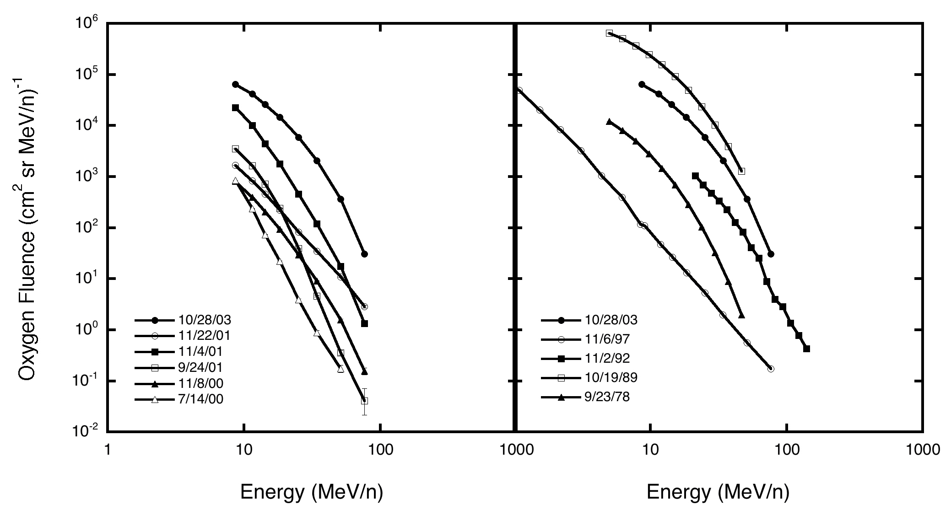
Figure 3. Oxygen fluences are plotted versus energy for the same 6 events given in the previous figure (left panel) and for 28 October 2003 event and other historically large events (right panel). Data for the 1978, 1989, and 1992 events are from Cook [1981], Garrard and Stone [1991], and Williams [1998], respectively.
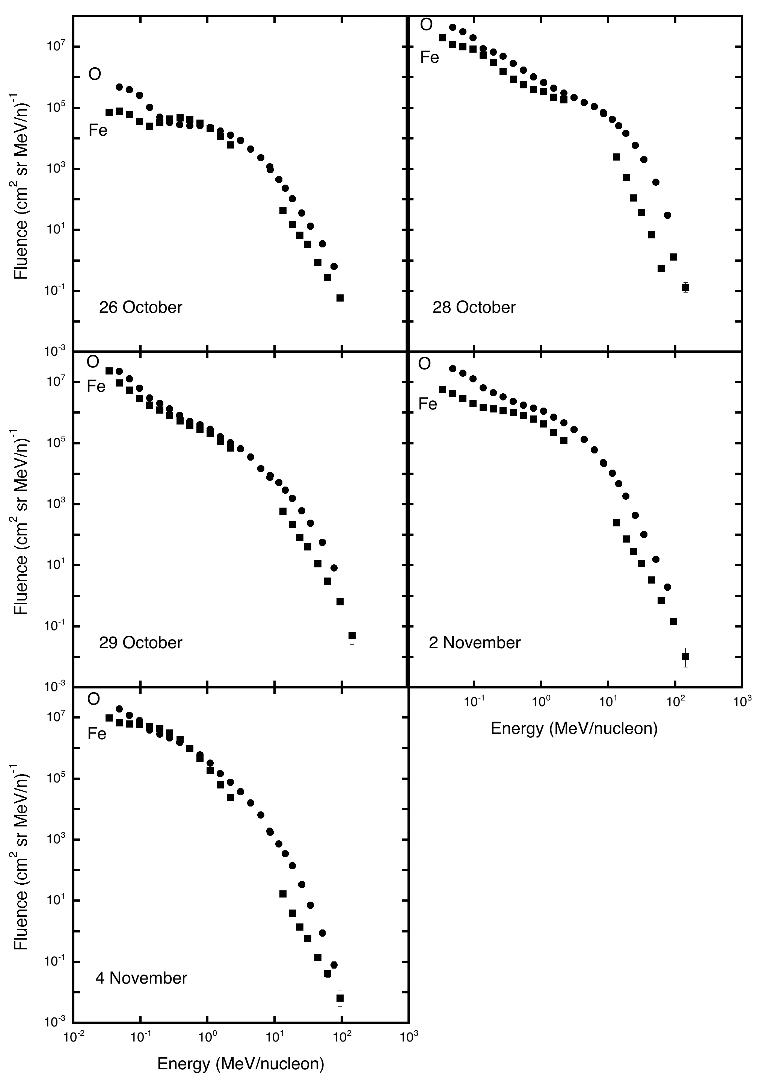
Figure 4. Event-integrated oxygen (circles) and iron (squares) fluences are plotted versus energy for each of the 5 events. The gap in the Fe spectra are due to different measurement techniques of the ULEIS and SIS sensors.
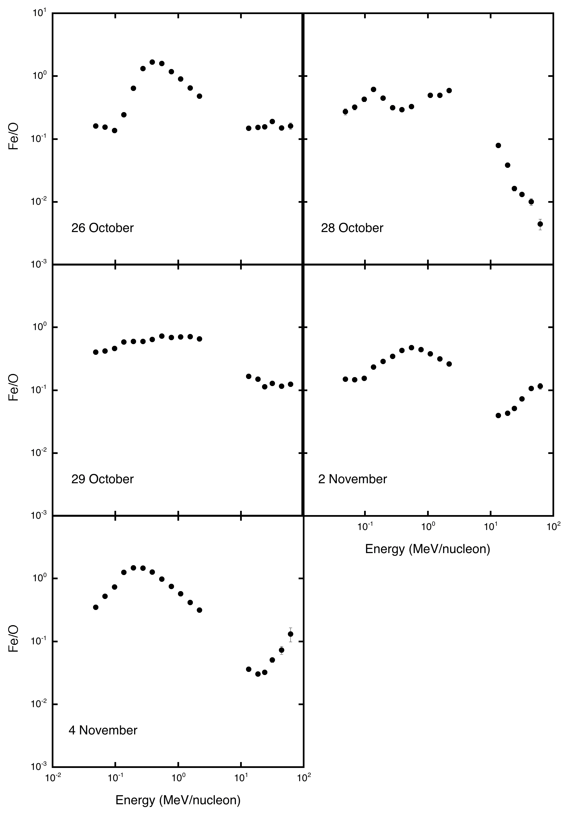
Figure 5. Iron to oxygen fluence ratios are plotted as a function of energy for the 5 events.
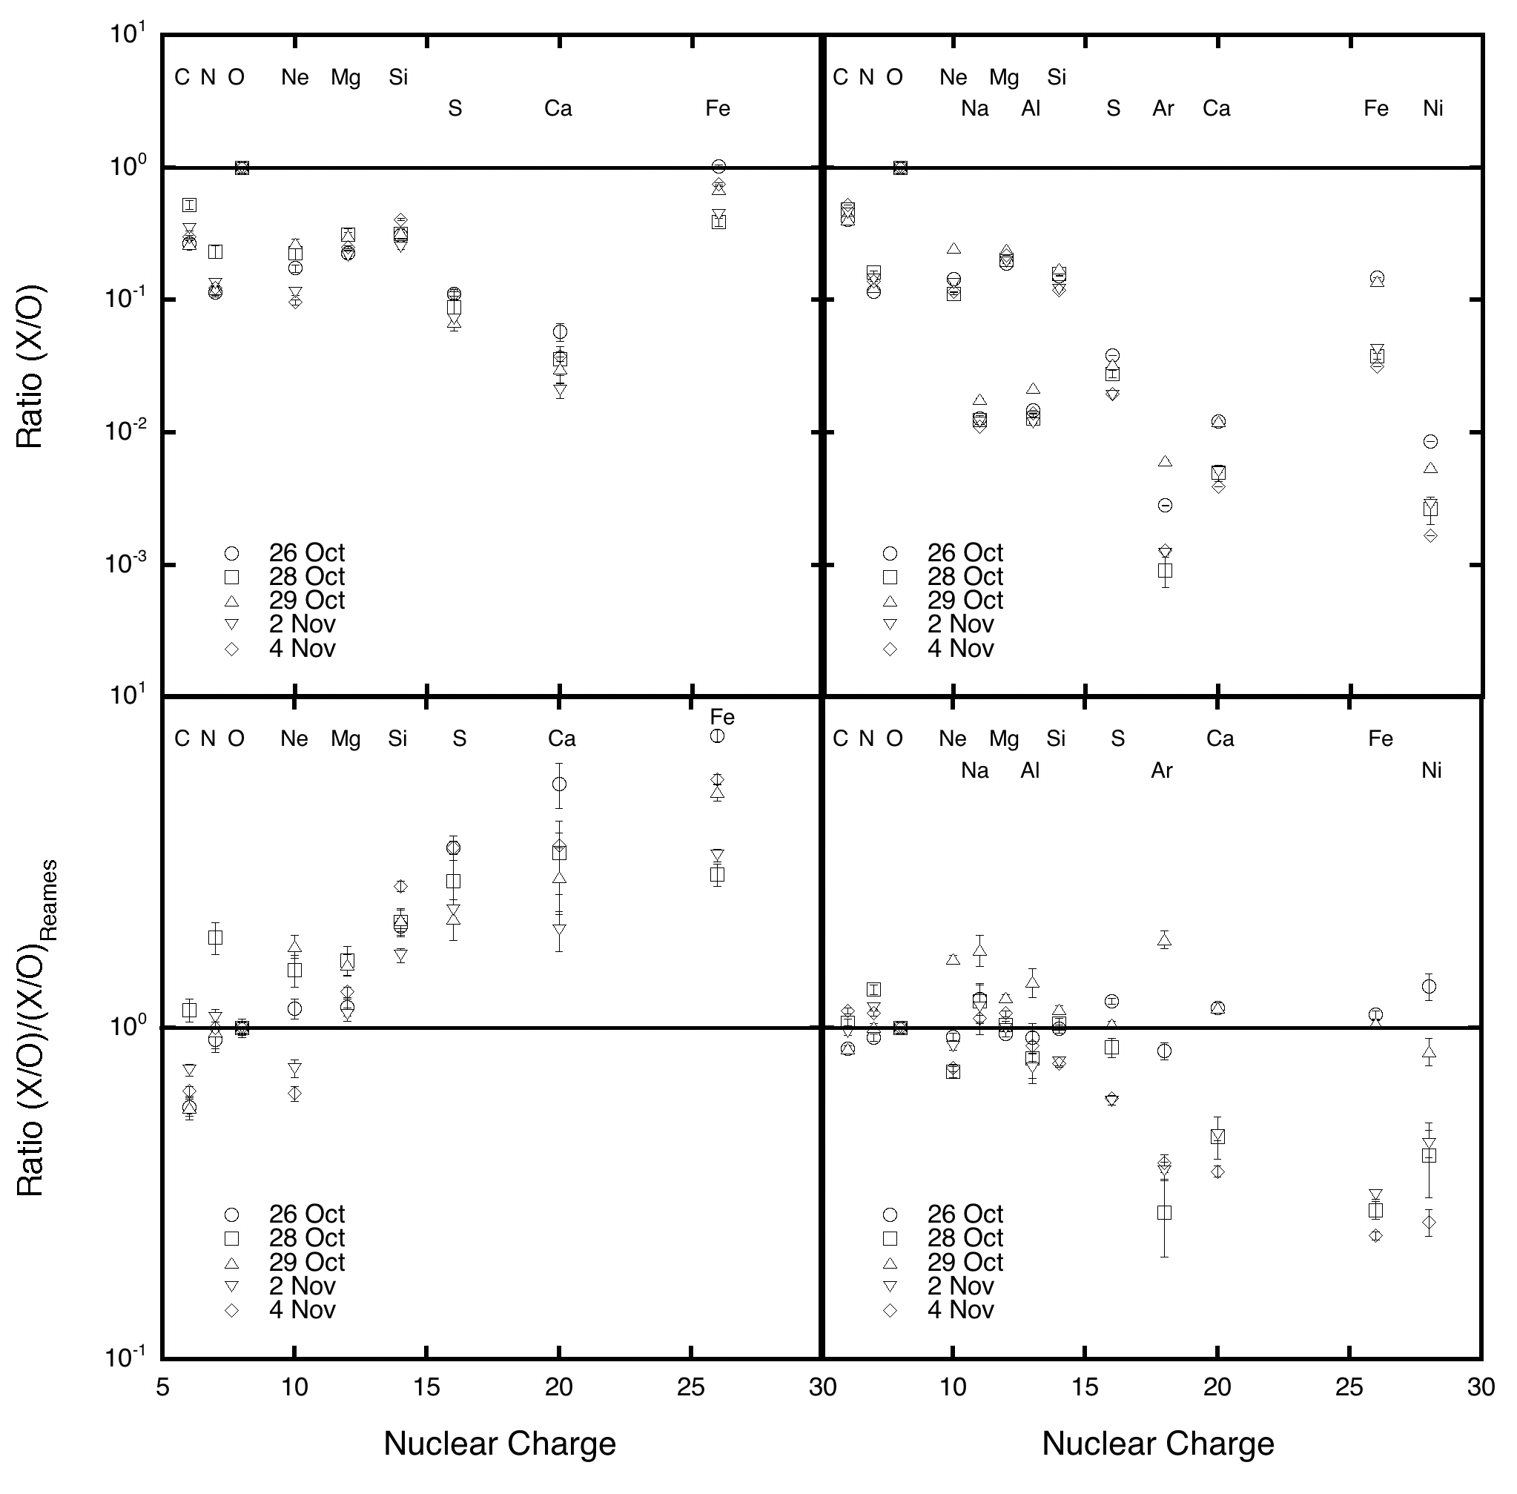
Figure 6. Event-integrated abundances relative to oxygen are plotted versus nuclear charge for two different energy ranges, 0.64 to 0.91 MeV/nucleon from ULEIS (left panels) and 12 to 60 MeV/nucleon from SIS (right panels). The bottom panels are further normalized to the large SEP event abundances of Reames [1999].

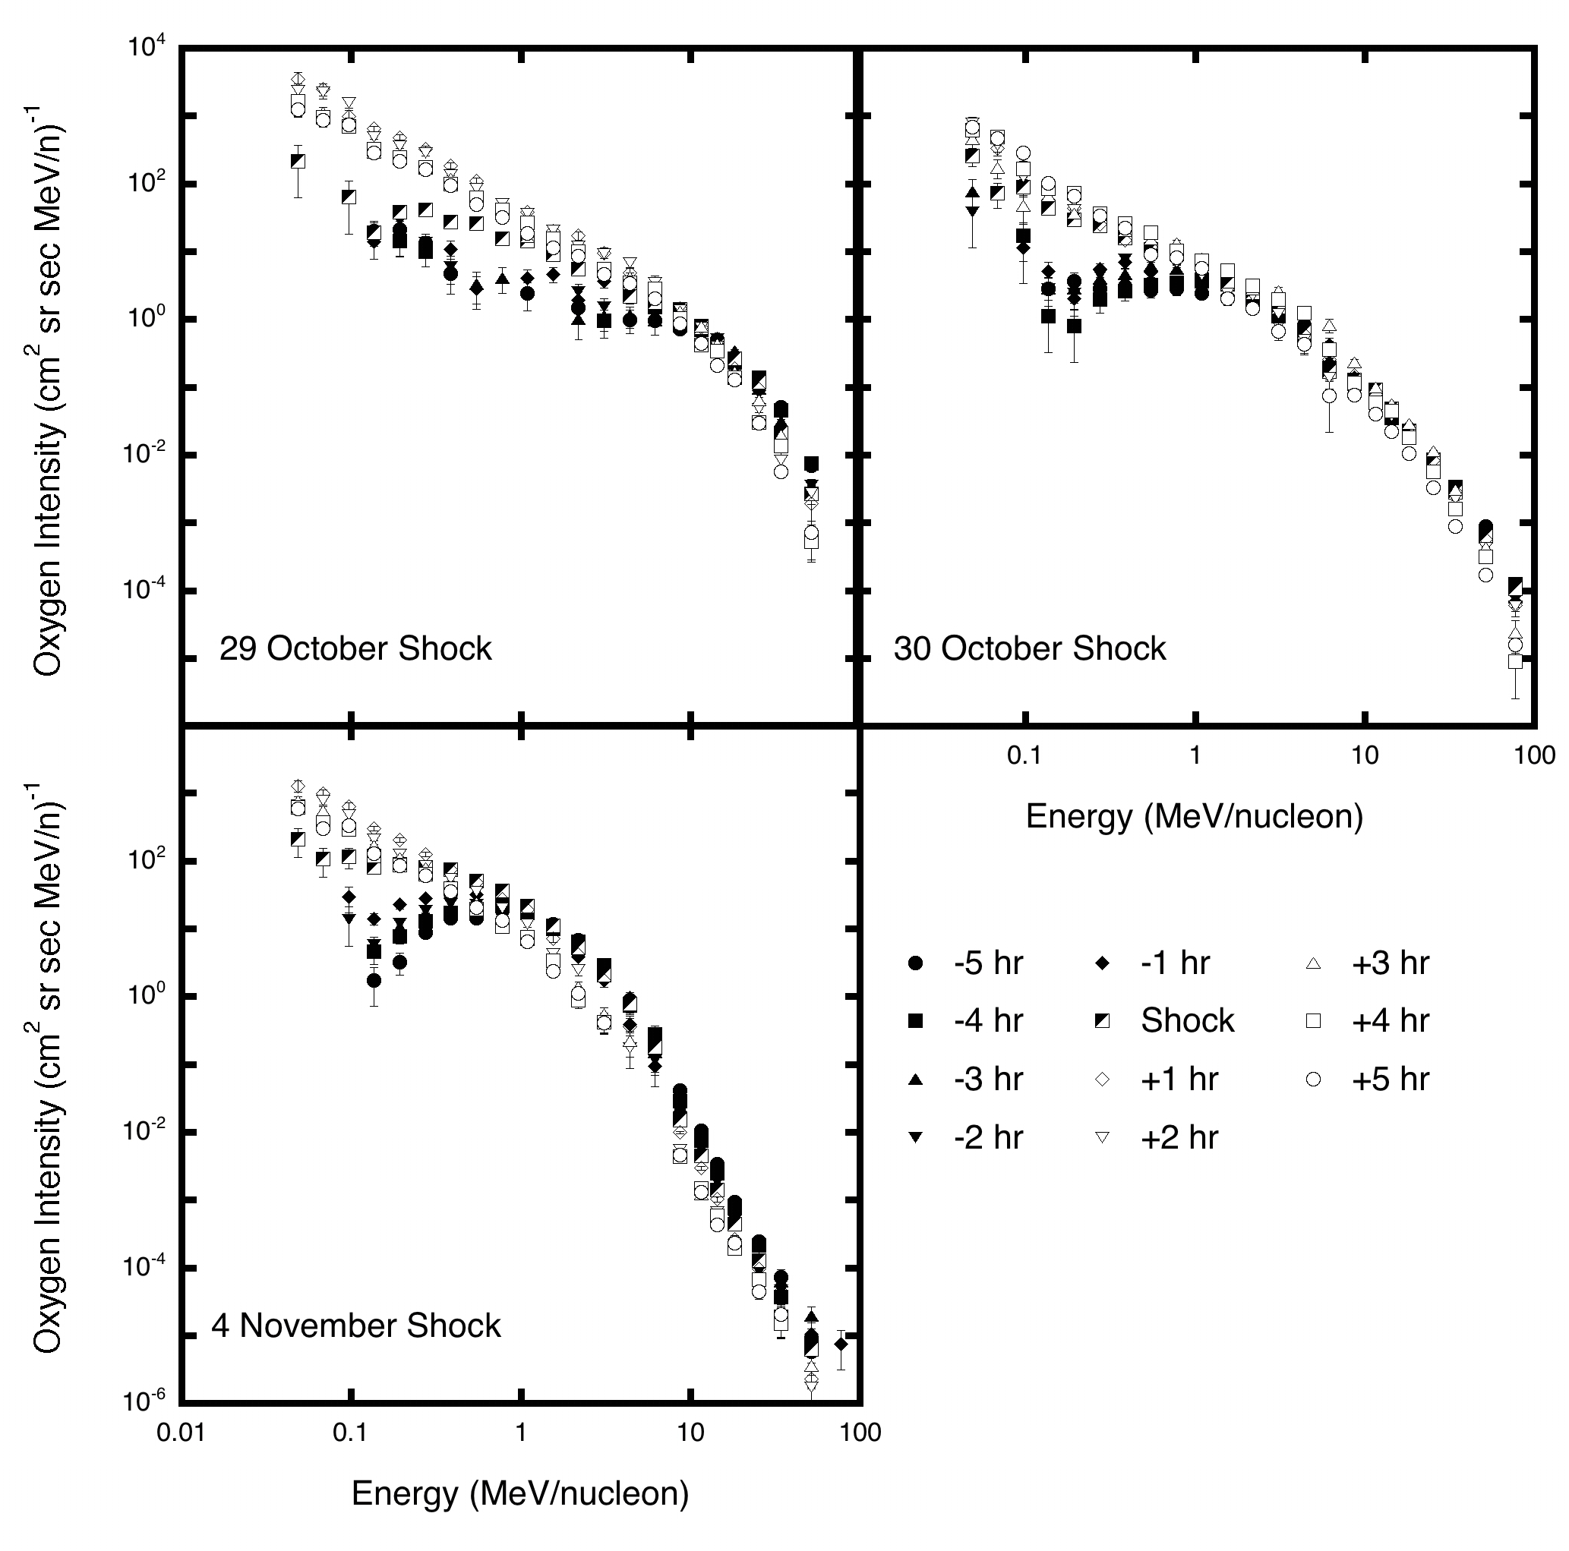
Figure 7. Hourly oxygen spectra are plotted as a function of energy for ±5 hours around the passage of 3 shocks (dates of the shock passages are given on the plots). Filled symbols indicate spectra before the shock passage, open symbols denote spectra after the shock passage, and the half filled squares indicate spectra during the hour of the shock passage.

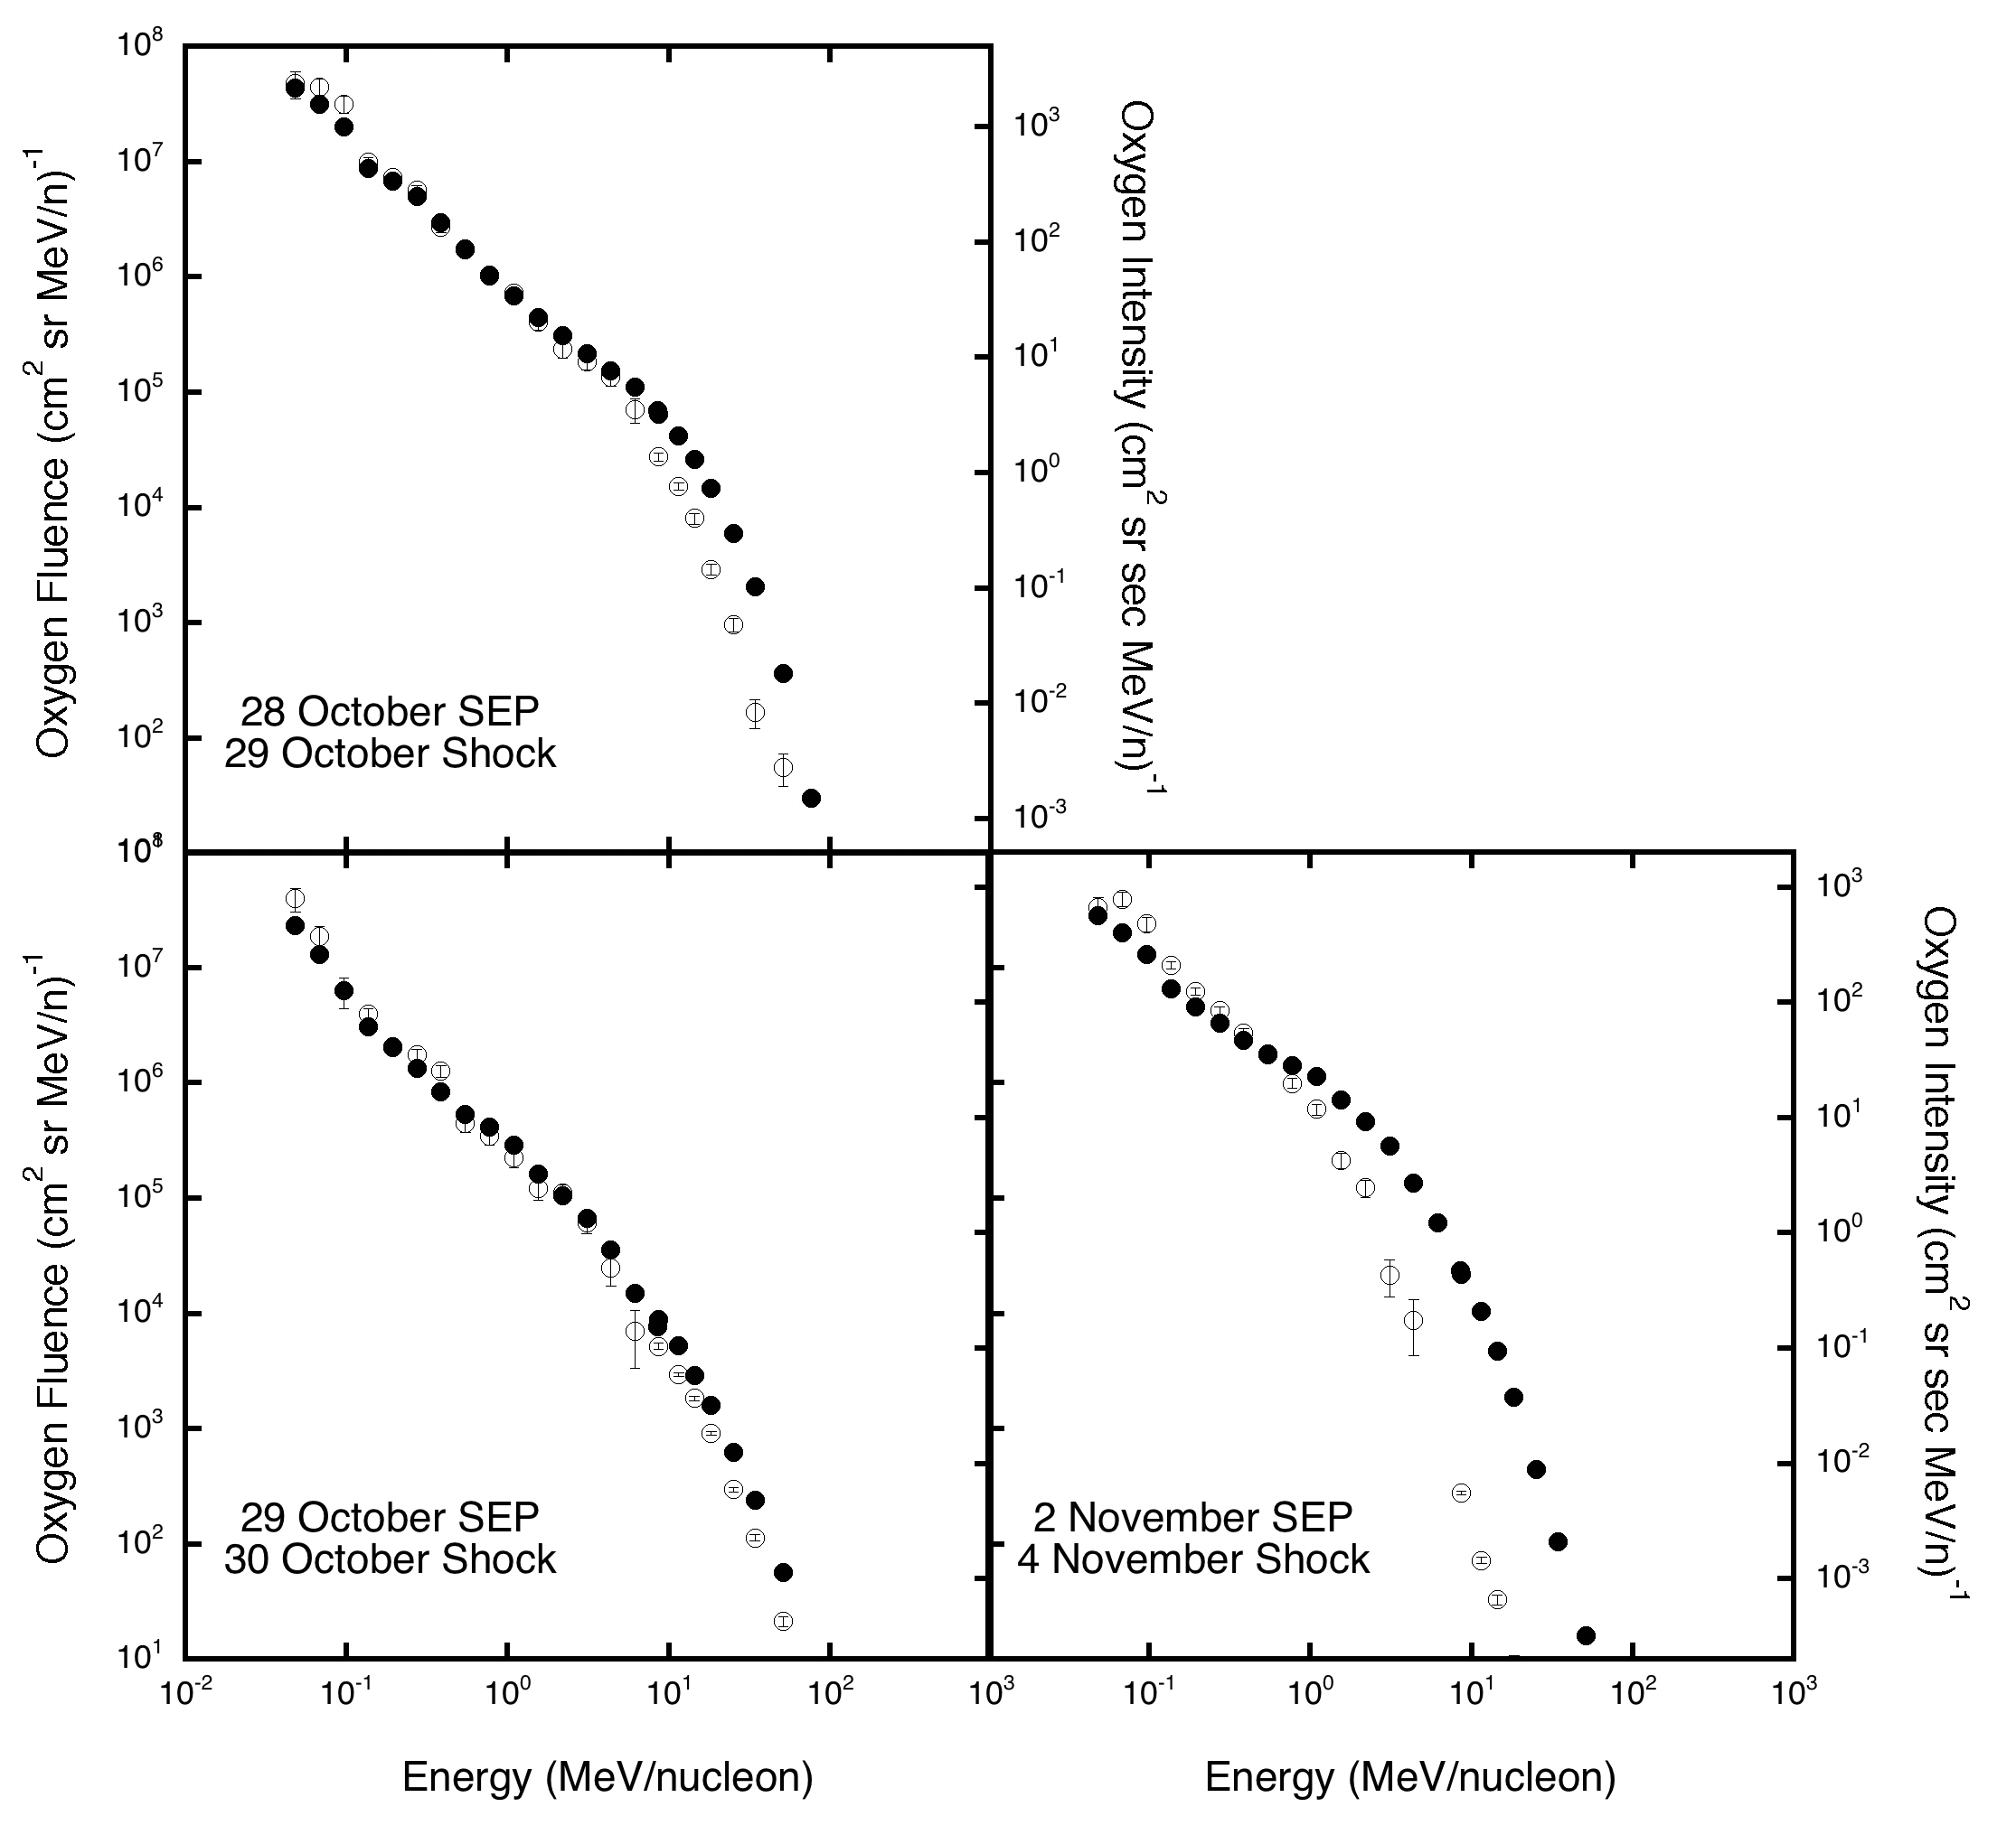
Figure 8. Event-integrated fluence spectra (left-side scales; solid points) for the events on 28, 29 October, and 2 November are compared to the intensity spectra (right-side scales; open points) obtained 2 hours after the passage of the shock (also shown in the previous figure) for oxygen. The shock intensity spectra have been vertically scaled by eye to better compare the spectral shapes.

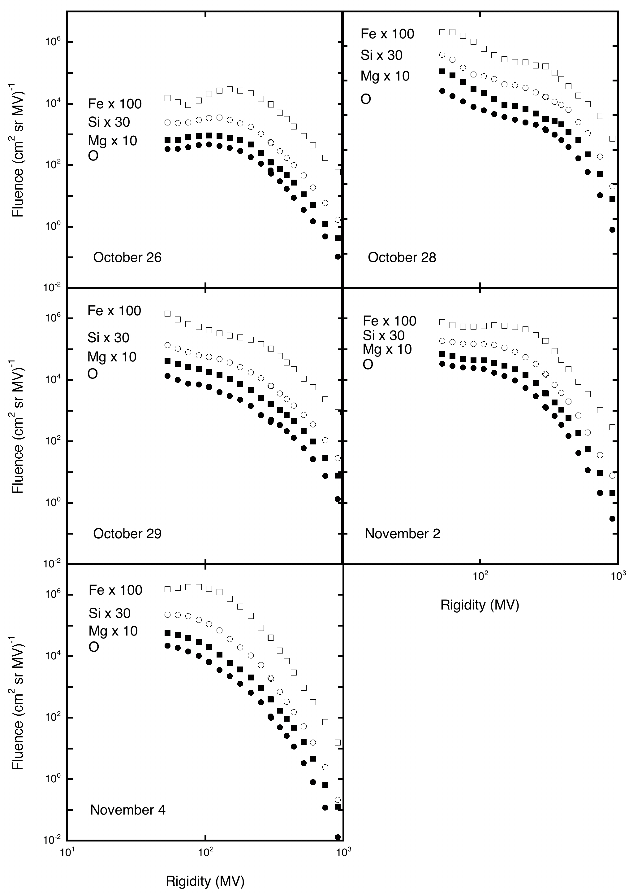
Figure 9. Event-integrated fluences are plotted versus rigidity for the 5 events. The Mg, Si, and Fe spectra have been scaled to better compare the spectral shapes.

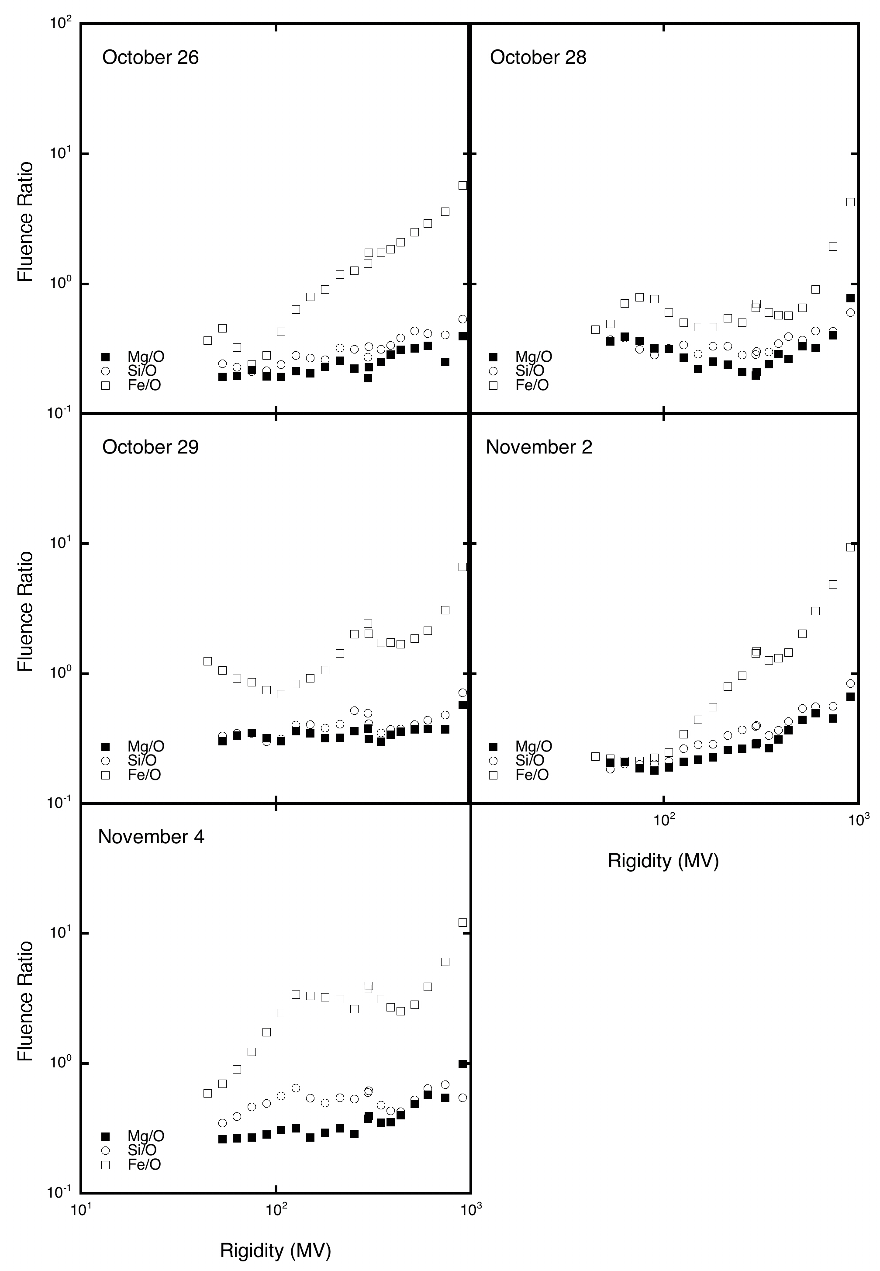
Figure 10. Ratios relative to oxygen are calculated from the spectra in the previous figure and plotted versus rigidity for the 5 events.

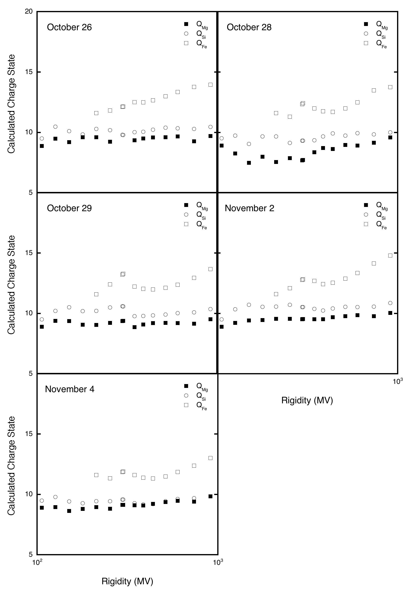
Figure 11. Calculated charge states for Mg, Si, and Fe are plotted versus rigidity for the 5 events.
Table 1: Related Solar Event Characteristics**
Event # | Flare Time | Flare Size | Flare Long | Active Region | CME Time | CME Speed | CME Width
1 | 26 Oct 17:21 | X1.2 | W38 | 10484 | 17:45 | 1537 | 171º
2 | 28 Oct 09:51 | X17 | E08 | 10486 | 10:54 | 1054 | 147º
3 | 29 Oct 20:37 | X10 | W02 | 10486 | 20:54 | 2029 | Halo
4 | 2 Nov 17:03 | X8.3 | W56 | 10486 | 17:30 | 2598 | Halo
5 | 4 Nov 19:29 | X28 | W69 | 10486 | 19:54 | 2657 | Halo
** Data are from Gopalswamy et al. [2004] and http://www.sec.noaa.gov/Data/index.html

Table 2: Shock Parameters**
Associated  Event # | Shock Time | θ_{Bn}  (deg) | Velocity  (km/s) | Mach Number | Transit Time*  (hours)
 | 26 Oct 08:09
 | 26 Oct 18:32 | 80 ± 3 | 631 ± 150 | 1.3 ± 0.1
1 | 28 Oct 01:31 | 68 |  |  | 32
2 | 29 Oct 05:58 | 14 |  |  | 19
3 | 30 Oct16:19 | 54 |  |  | 19
4 | 4 Nov 05:59 | 43 ± 4 | 779 ± 34 | 4.4 ± 0.7 | 36
5 | 6 Nov 19:19 | 66 ± 6 | 524 ± 40 | 3.0 ± 0.7 | 47
* measured relative to corresponding CME
**Data from http://www-ssg.sr.unh.edu/mag/ace/ACElists/obs_list.html

Table 3: SIS Time Intervals and Selected Energy Values
Event # | Start Time | Stop Time | E_{shock} (MeV/n) | E_{prompt} (MeV/n)
1 | 26 Oct 14:47 | 28 Oct 00:00 | ** | 1.5
2 | 28 Oct 10:30 | 29 Oct 18:37 | 8.6 | 51
3 | 29 Oct 21:00 | 31 Oct 09:33 | 8.6 | 51
4 | 2 Nov 16:55 | 4 Nov 17:25 | 0.77 | 6.2
5 | 4 Nov 21:31 | 7 Nov 12:00 | 0.10 | 0.19
** below measured energies

Table 4: Calculated Charge States
Event # | Q_{Mg} Calc 900 MV | Q_{Si} Calc 900 MV | Q_{Fe} Calc 900 MV | Q_{Mg} % increase | Q_{Si} % increase | Q_{Fe} % increase
1 | 9.7 | 10.5 | 14.0 | 9 | 11 | 21
2 | 9.6 | 10.0 | 13.8 | 8 | 5 | 19
3 | 9.5 | 10.4 | 13.7 | 7 | 9 | 18
4 | 10.1 | 10.9 | 14.8 | 13 | 15 | 28
5 | 9.8 | 9.7* | 13.0 | 10 | 2* | 12
* at 740 MV

